Ideation Phase
Define the Problem Statements

Date | 01 MAY 2023
Team ID | NM2023TMID11342
Project Name | CovidVision: Advanced COVID-19  Detection from lung x-ray with mechine learning or Deep learning
Maximum Marks

Customer Problem Statement:
User from the department of covid vision.The imaging tool, such as Chest X-ray (CXR), can speed up the identification process. Therefore, our objective is to develop an automated CAD system for the detection of COVID-19 samples from healthy and pneumonia cases using CXR images.

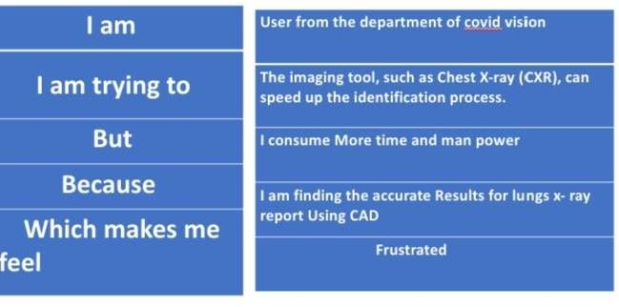

Problem  Statement (PS) | Iam  (Customer) | I’m trying to | But | Because | Which makes me feel

Covid vision detection | User from the department of covid vision | The imaging tool, such as Chest X-ray (CXR), can speed up the identificatio  n process. | It consumes lot of time and man | We are finding the covid vision using CAD  . | Frustrated and exhausted.

